Project Design Phase-II
Data Flow Diagram & User Stories

Date | 15 July 2026
Team ID | SWTID-2026-9567
Project Name | AI Powered Debt Relief & Financial Recovery Platform
Maximum Marks

Data Flow Diagram (DFD)

A Data Flow Diagram (DFD) illustrates how information flows through the FinRelief AI system. It shows how user financial data is collected, processed, analyzed by AI, stored in the database, and displayed as personalized financial recommendations.

Level-0 DFD (Simplified)
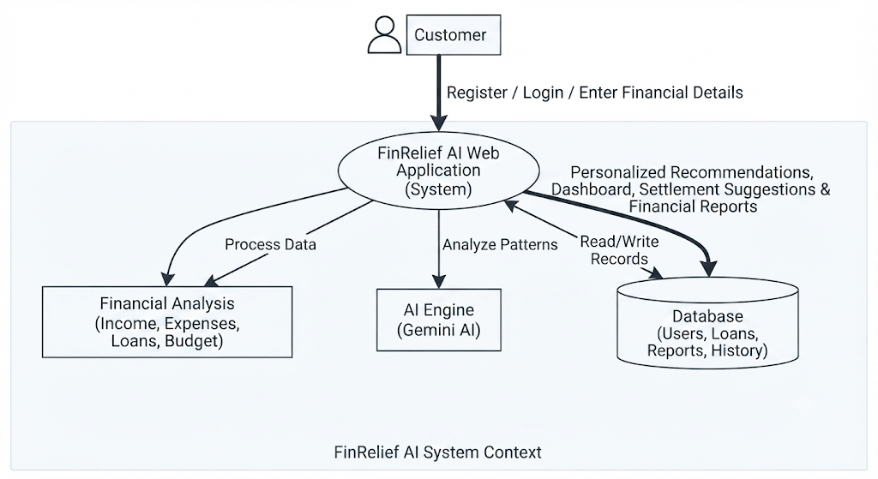

Table: User Stories
User Type | Functional Requirement (Epic) | User Story No. | User Story / Task | Acceptance Criteria | Priority | Release
Customer (Web User) | Registration | USN-1 | As a user, I can register using my name, email, and password. | User account is created successfully. | High | Sprint-1
Customer (Web User) | Login | USN-2 | As a user, I can log in using my email and password. | User accesses the dashboard successfully. | High | Sprint-1
Customer (Web User) | Financial Profile | USN-3 | As a user, I can enter my income, expenses, and loan details. | Financial profile is saved correctly. | High | Sprint-1
Customer (Web User) | Dashboard | USN-4 | As a user, I can view my financial summary and recommendations. | Dashboard displays updated information. | High | Sprint-1
Customer (Web User) | Financial Analysis | USN-5 | As a user, I can analyze my financial health. | AI generates financial analysis successfully. | High | Sprint-2
Customer (Web User) | Settlement Recommendation | USN-6 | As a user, I can receive AI-based debt settlement suggestions. | Personalized recommendations are generated. | High | Sprint-2
Customer (Web User) | Budget Planning | USN-7 | As a user, I can receive budgeting and savings recommendations. | AI provides budget suggestions. | Medium | Sprint-2
Customer (Web User) | Report Generation | USN-8 | As a user, I can view and download my financial report. | Report is generated successfully. | Medium | Sprint-3
Administrator | User Management | USN-9 | As an administrator, I can manage user accounts. | User records can be viewed and updated. | High | Sprint-3
Administrator | Database Management | USN-10 | As an administrator, I can manage financial records and reports. | Database operations execute successfully. | High

